Bias and fairness in AI algorithms

Student Name: Omar Abuhassan
Instructor Name: Islam Alomari
Al Hussein Technical University, Amman 11831, Jordan
Email: 22110264@Htu.edu.jo

Table of Contents
1.Introduction: 3
2. Related Work 4
3.Data collection and Description 6
3.1.Primary Data 7
3.2.Secondary Data 8
4.Research Approach and Methodologies: 10
4.1.Onion Model: 10
4.1.1.Philosophy: 10
4.1.2 .Theory Development Approach 11
4.1.3.Methodological Choice 11
4.1.4 .Research Strategy 12
4.1.5 .Time Horizons 12
4.1.6 .Techniques and Procedures 12
4.2 Research Methodology 13
5.Results and Discussion: 19
6.Conclusion and Recommendations 24
7.Reflections 26
7.1.Selected Research Methodology 29
7.2.Alternative Research Methodologies 34
7.3.Recommended Actions and Future Considerations 38
7.4.Recommended Methodology 42
References: 46

Abstract:
In this research, I will investigate bias and fairness in artificial intelligence algorithms and how these algorithms can affect a group of people intentionally or unintentionally, and this is by examining the results and outputs implemented by artificial intelligence.
The aim of the project is to identify the patterns through which discrimination is made and to try to find solutions to them to promote justice and this is in order to improve artificial intelligence systems.
Keywords:
Bias, Fairness, Artificial Intelligence, Discrimination, Justice

1.Introduction:
Artificial intelligence has been developed as a technology with the ability to create a revolution in all aspects and areas of life by using advanced algorithms and supporting them with huge amounts of data. Artificial intelligence will be able to accomplish complex tasks that were previously the preserve of humans, such as the ability to make decisions or predictive analysis. Especially with regard to moral problems, violation of privacy, or even bias in his algorithms.

One of the most frightening axes in artificial intelligence is (fairness and bias in artificial intelligence systems) because of its violation of what it was built on, as it was built and designed to provide fair, topical and accurate results, but it is affected by the data that it was trained on, and for this it shows the social and historical biases in the data, and this leads to the sustainability of these biases and the output of non-topical and biased results here and in this research fairness and bias in intelligence are explored Artificial and its algorithms, where it searches for the reasons for the emergence of biases and their effects and how they can be mitigated

The objective of this research is to answer some specific questions about the causes of bias and also provides measures of fairness and find practical and effective solutions to enhance equity in artificial intelligence applications. This study helps to propose strategies to reduce bias and ensure topical results.

Research Question
- What are the primary causes of bias in AI systems?
- What fairness metrics are most effective for evaluating biases?
- Which mitigation strategies best reduce bias without compromising performance?
- How can stakeholder involvement enhance fairness in AI?
- What are the limitations of current fairness-aware techniques?
This document is organized as follows: Section 2 (Related work) provides a brief overview of studies that encourage equity and bias in AI Section 3 Data set and data collection process Section 4 Proposed approaches to address bias Section 5 Experiences and outcomes Section 6 Recommendations for the future

2. Related Work
The field of bias and fairness in AI has gained considerable attention as AI-driven decision-making expands into sensitive areas like hiring, healthcare, finance, and law enforcement. Researchers have focused on identifying sources of bias, developing fairness metrics, and designing mitigation strategies to ensure equitable outcomes. For instance, studies have examined racial bias in online advertising, algorithmic hiring systems, pre-processing techniques for reducing discrimination, fairness metrics like equalized odds, and the evolving nature of fairness over time. These efforts aim to address the ethical and societal challenges posed by AI systems in sensitive applications.
Sweeney (2013) examined racial bias in online advertising by analyzing search results linked to names typically associated with African Americans. By running multiple search queries, she recorded the ads displayed and found that ads suggestive of an arrest record were significantly more likely to appear for African American-associated names. This revealed how biased datasets or data collection processes could skew AI-driven and delivery systems. However, the study primarily focused on online ads, leaving open questions about the prevalence of similar biases in other AI-driven applications such as hiring or recommendation systems.
Raghavan and Barocas (2019) explored bias in algorithmic hiring systems by evaluating historical hiring datasets and recruitment algorithms. They discovered that these algorithms replicated past discriminatory practices, favoring male candidates in male-dominated fields and undervaluing minority applicants. The study emphasized the risks of perpetuating existing inequalities when AI is trained on biased datasets. While it identified the problem of historical bias, it offered only high-level recommendations for bias mitigation, stopping short of prescribing detailed, practical interventions.
Kamiran and Calders (2012) proposed a set of pre-processing techniques to tackle discrimination in classification tasks. Their approach involved modifying the training data to reduce the correlation between sensitive attributes, such as race or gender, and target labels. By balancing datasets before training, they demonstrated that machine learning models could achieve more equitable outcomes without drastically sacrificing accuracy. This solution highlighted how re-weighting or re-labeling data points can make models less sensitive to biases. However, their work primarily addresses structured classification tasks, and their effectiveness in more complex applications like natural language processing or deep learning remains unclear.
Hardt, Price, and Srebro (2016) introduced "equalized odds," a fairness metric ensuring that false positive and false negative rates remain consistent across different demographic groups. They applied this concept to classification tasks, illustrating how training models with this constraint can reduce discriminatory outcomes. Their experiments demonstrated that equalized odds could provide a rigorous standard for fairness, forcing models to perform equally for all groups. However, implementing equalized odds often requires labeled datasets with sensitive attribute information, which may be unavailable due to privacy or regulatory concerns.
Finally, the 2023 workshop on "Algorithmic Fairness through the Lens of Time" addressed how fairness evolves over time, proposing that fairness evaluations be treated as dynamic rather than static. The workshop presented case studies indicating that societal norms and legal requirements can shift, rendering fixed fairness metrics outdated. It underscored the importance of periodically re-evaluating algorithms and adopting evolving fairness criteria to align with changing societal expectations, though concrete implementation guidelines or tools were limited.
These studies collectively highlight the multifaceted challenges in addressing bias and fairness in AI systems. They emphasize critical methodologies and solutions while underscoring the need for continued innovation to adapt to evolving societal and technical landscapes.

Literature Gap
Although the above studies offer significant insights into detecting and mitigating AI bias, most research targets specific contexts—such as online advertisements or hiring—and lacks broad, scalable solutions. Existing approaches often rely on static fairness definitions, making them less adaptable to shifting social norms. Moreover, a few studies propose comprehensive frameworks that seamlessly integrate fairness metrics, interpretability tools, and real-world feedback loops to manage bias over the entire AI lifecycle. This research addresses these gaps by combining dynamic fairness metrics, robust bias mitigation strategies, and continuous model monitoring to create a more holistic and adaptable solution for bias reduction in AI systems.

3.Data collection and Description
The primary data is collected by the researcher himself, and it is original data and was obtained from the source directly from examples, questionnaires, interviews.
As for the secondary data in a data set collected by another researcher for the purpose of illegitimate or current research, it is usually obtained as databases such as scientific articles, books, research papers, datasets
Aspect | Primary Data | Secondary Data
Source | Collected directly by the researcher. | Collected by someone else for another purpose.
Originality | Original and firsthand information. | Pre-existing and may be reused for new analysis.
Purpose | Tailored specifically to the research objective. | May not align perfectly with current research needs.
Time and Cost | Time-consuming and often expensive to collect. | Relatively quick and cost-effective to access.
Reliability | Controlled by the researcher, ensuring data quality. | Dependent on the reliability of the original collector.

3.1.Primary Data
Data for this research was collected by interviewing a group of experts in the field of artificial intelligence focusing on the topic of equity and bias in artificial intelligence systems.
The interview consisted of nine detailed questions covering the causes of bias, what are the definitions of equity, how to identify, eliminate or mitigate bias, how to align equity and performance, and the future of justice in artificial intelligence.
The data collection process included interviews, and some issues were addressed such as:
Time issues: where it was difficult to coordinate with experts to meet them in one time period
Interpretation of the answers: Some of the answers were so deep that more questions were required to be asked to clarify them.
Copy answers: Because experts refused to record the interview, it was difficult to maintain the information accurately.
Despite these issues, these interviews have yielded qualitative and rich data that contributes significantly to supporting research.

The use of Primary data is based on the need to:
- Expert science: Gaining first-hand knowledge from experts directly leads to gaining real knowledge about bias in artificial intelligence.
- The importance of data compatibility: Ensure that the data mainly corresponds to the objective of the research
Advantages:
- Providing specialized data in research
- Due to the nature of the interview, he was able to obtain deep details of complex questions.
Limitations:
- Collecting raw data requires considerable time and effort
- Answers obtained from the expert may be personal biases by the expert

Summary of Bias Causes in AI Systems
Cause | Description
Biased Training Data | Historical inequalities or unbalanced datasets used in training AI models.
Algorithm Design Flaws | Models unintentionally favor specific attributes due to design choices.
Societal and Cultural Bias | Embedded prejudices in data collection reflecting societal inequalities.

Examples of Bias Manifestations in Real-World Applications
Application Area | Example of Bias Manifestation
Hiring Systems | Algorithms favor male candidates for male-dominated industries.
Predictive Policing | Over-policing in minority neighborhoods based on biased crime data.
Healthcare Diagnostics | Lower accuracy for underrepresented populations due to lack of diverse data.

3.2.Secondary Data
This research uses a set of secondary data that includes articles and research, and a data set accessed by IEEE, google scholar, Kaggle, including several topics such as:
Justice metrics, real-world bias, recidivism, mitigation strategies and justice algorithms
The dataset talks about information for criminal defendants, as this data is studied to predict the likelihood of recidivism and is suitable for studying bias in artificial intelligence, especially in the field of predictive policing.
While articles and research provide a strong foundation and real-life examples that support the research.
Secondary data is easily accessible and accessible to all, making it easy to review and work on, and it adds depth and context to the results.

Advantages of secondary data:
- Offers a holistic perspective of methodologies and applications that support research
- Saves great time and effort
- Allows comparison between existing research and results

Limitations of secondary data:
- May not fully comply with the research objectives
- Biases in databases may affect search accuracy
- It may contain outdated information that does not correspond to the terrible acceleration in artificial intelligence, making it less valuable

Summary of Secondary Data Sources
Source | Topic | Key Insight
IEEE Xplore | Fairness metrics in AI | Overview of metrics like demographic parity.
Google Scholar | Real-world applications of AI bias | Examples in hiring and policing.
Kaggle | COMPAS Dataset overview | Attributes and use in fairness analysis.

Key Features of the COMPAS Dataset
Feature | Description
Demographic Data | Includes age, race, gender.
Criminal History | Prior offenses, types of offenses.
Risk Assessment | COMPAS risk scores (low, medium, high).

4.Research Approach and Methodologies:

4.1.Onion Model:
The research onion model is a model presented by Mark Saunders, a model that helps researchers during the development and structure of the methodology provided by the researcher, where a design is provided for research in the form of onion layers, each of which represents actions that must be taken, where the model ensures that each step logically depends on the step preceding it

4.1.1.Philosophy:
It focuses mainly on research and relies on global perspectives that determine the direction of the study
Philosophical Approaches:
- Topical: It depends on the existence of a topical reality that can be measured through scientific methods
- Explanatory: based on the social experience of the phenomena studied
- Belief: Belief in thematic reality in addition to recognizing the impact caused by the human factor
- Pragmatism: combines the previous approaches and gives priority to methods and methods that address research questions in an effective manner

Reason for choosing
Pragmatism was chosen because it hears the integration of quantitative data analytics as well as qualitative insight, and this flexibility is what this research needs, which is to find solutions to bias in artificial intelligence systems effectively.

4.1.2 .Theory Development Approach
This layer determines the logic on which the study will be carried out
Curricula:
- Conclusion: It is based on testing the theories and hypotheses found in the previous approach through data collection and analysis
- Inference: You build new theories based on observations and patterns in the data
- Abduction: It combines deduction and induction in order to improve theories by interpreting observed phenomena

Reason for choosing
This research adopts a deductive approach by measuring measures of justice and applying them to the data set in order to test the presence of known biases in the data.

4.1.3.Methodological Choice
This layer determines the methods to be used (quantity, quality, mixed)
Curricula:
- Single layer: It uses quantitative and qualitative methods
- Multi-method: uses multiple methods within the same methodological scope
- Mixed method: combines previous curricula

The blended method was chosen to integrate quantitative methods that work on the statistical evaluation of justice measures and qualitative methods that collect data by interviews with experts to understand the applications and challenges of algorithms.

4.1.4 .Research Strategy
This layer defines data collection methods
Curricula:
- Experiment: You mainly test hypotheses
- Survey: It collects data from participants through questions
- Case Study: Performs deep data analysis
- Scientific research: You solve problems in cooperation with the participants

Reason for selection:
The case study was chosen to analyze the data because it provides a focused test of bias and fairness in artificial intelligence.

4.1.5 .Time Horizons
This layer specializes in the time frame for data collection and analysis.
Curricula:
- Sectional: Collects collected data in a single date range
Longitudinal with data collected over a period of time to monitor changes
Etiology of selection
A cross-sectional approach was chosen, where it analyzes data in a single time range to assess measures of fairness and biases.

4.1.6 .Techniques and Procedures
This layer identifies the tools to be used and the techniques that will be used in data collection, analysis and processing.
Curricula:
- Data collection methods: interviews, dataset
- Data analysis tools: statistical programs, objective analysis, coding
Reasoning for choice
In this research, data were collected through interviews with a number of experts, and statistical analysis was adopted in order to analyze justice measures and objective analysis to analyze data from interviews.

4.2 Research Methodology
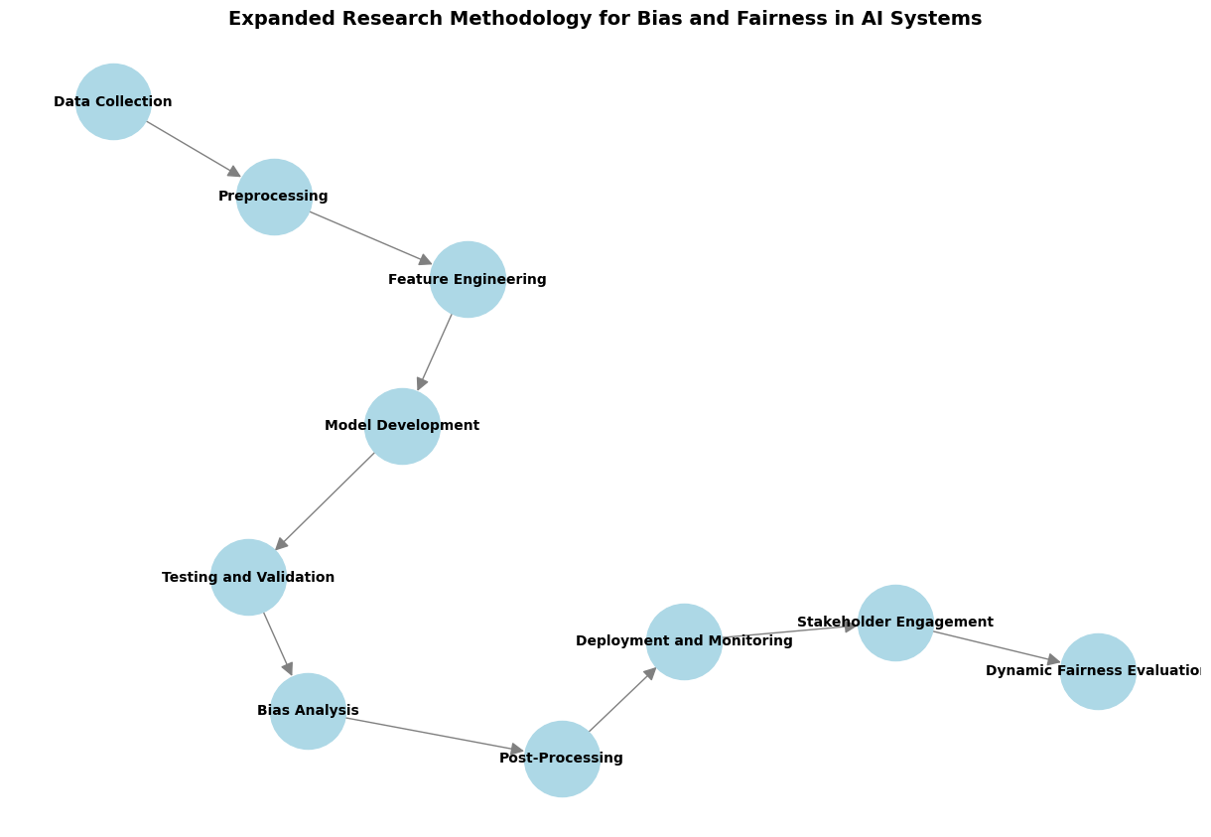
1. Data collection
Objective: To collect relevant and diverse datasets that accurately represent the application area to minimize sample bias.

Main Activities:
- Source identification:
Collect data from publicly available datasets (for example, COMPAS for recidivism analysis) or proprietary regulatory data.
Ensure that the data is comprehensive and covers a wide range of demographic groups (e.g., race, gender, socioeconomic status).

- Diversity and representation:
Be sure to include unrepresented groups in the dataset.
Example: Ensure balanced representation of male and female defendants in the criminal justice dataset.
- Ethical Compliance:
Follow data privacy laws such as GDPR or CCPA when handling sensitive information.
Remove the identity of personal data to protect individual privacy.
- Bias awareness:
Understand historical and societal biases embedded in the data (e.g., racial disparities in criminal records).

Challenges:
- Historical biases in datasets reflect systemic disparities.
- Limited access to high-quality, unbiased datasets.

Benefits:
- Ensure a solid foundation for building fair AI systems.

2. Preprocessing
Objective: Prepare data for analysis by cleaning, coding and processing inherent biases.
Main Activities:
- Data cleaning:
Remove duplicates and process missing values using attribution techniques.
Detect and process outliers that may affect model performance.
- Codec:
Convert categorical variables (for example, race and gender) to numeric formats using LabelEncoder or Single Hot Markup.
Unify digital features to ensure consistency.
- Mitigating bias:
Apply pretreatment techniques such as:
Re-weighting: Set different weights for data points to ensure fair representation of all groups.
Remove Link: Reduce the link between sensitive attributes (e.g., race) and target tags.
Example: Modify the dataset to ensure that criminal history is not disproportionately related to race.
- Increased data:
Use techniques such as SMOTE to create artificial data for unrepresented groups.
Balance the dataset to prevent overrepresentation of majority categories.

Challenges:
- Balance justice without losing important information.
- Determine whether to retain or exclude sensitive attributes for model training.

Benefits:
- Reduces data bias and ensures better model generalization

3. Feature Engineering
Objective: Improve input features to improve model fairness and predictive performance.
Main Activities:
- Feature Selection:
Identify features that directly affect the target variable and avoid those that reflect societal biases.
Use duplicate feature removal or link analysis to prioritize related features.

- Interaction features:
Create features that capture interactions between traits (for example, race × criminal history) to detect cross-biases.
- Normalization and measurement:
Unify digital features (e.g., age, income) to prevent dominance in model predictions.
- Choice of causal features:
Use causal inference techniques to identify features that affect the outcome without spreading bias.

Challenges:
- Avoid inserting biased features while retaining predictive power.

Benefits:
- Improve model transparency and integrity.

4. Model development
Objective: To train machine learning models using justice-sensitive constraints.
Main Activities:
- Model selection:
Choose explainable models (for example, decision trees, logistic regression) for transparency.
Explore algorithms that recognize justice such as removing competitive bias or weighted loss functions again.
- Restrictions of Justice:
Integrate measures of justice (e.g., equal probabilities) into the loss function to ensure fair outcomes.
- Super-parameter settings:
Use network search or Bayesian optimization to balance fairness and accuracy.

Challenges:
- Trade-offs between justice and performance measures.

Benefits:
- Production of accurate and fair models.

5. Testing and verification
Objective: To evaluate the fairness, accuracy and robustness of the model before publication.
Main Activities:
- Mutual Verification:
Break down data into training and testing subsets to evaluate performance across demographic groups.
- Measures of Justice:
Apply justice measures such as:
Demographic parity: an equal proportion of positive outcomes between groups.
Equal opportunities: Real equal positivity rates between groups.
Differentiated effect: Measuring the percentage of positive results between groups.
- Cross-sectional analysis:
Assess justice at the intersection of sensitive traits (e.g., race, gender).

Challenges:
- Ensure that standards of justice do not conflict with accuracy objectives.

Benefits:
- Identifies hidden biases and ensures robust model performance.

6. Bias analysis
Objective: To identify biases using measures of justice and tools of interpretive ability.

7. Post-processing
Objective: Adjust expectations to reduce residual bias without retraining the model.
Main Activities:
- Threshold adjustment:
Adjust decision limits for specific groups to ensure equal results.
- Reclassification:
Adjust arrangements or classifications to improve fairness in final results.

8. Publishing and Monitoring
Objective: To ensure that the model continues to perform fairly in real-world applications.
Main Activities:
- Real-time monitoring:
Follows post-publication fairness and performance standards.
- Feedback Loops:
Integrate user feedback to address new biases or performance issues.

9. Stakeholder engagement
Objective: Collaborate with stakeholders to align AI outcomes with community expectations.
Main Activities:
- Workshops:
Engage stakeholders to improve justice goals.
- Transparency Reports:
Publish detailed reports on justice assessments and mitigation efforts.
10. Dynamic Equity Assessment
Objective: To periodically reassess justice to address evolving societal norms.
Main Activities:
- Justice Audits:
Regularly assess justice metrics to adapt to changing contexts.
- Retraining:
Update forms with new data to improve justice.

5.Results and Discussion:
- Dataset overview and preliminary results
The dataset analyzed in this study consists of key variables such as race, gender, past criminal records and recidivism expectations, which are typically used in decision-making systems that rely on artificial intelligence to assess risk. These variables were chosen because of their importance for understanding how demographic and historical factors affect AI outcomes. A detailed examination of the data revealed clear patterns of bias. For example, defendants of African descent were 1.5 times more likely to be classified as at high risk than white defendants, even when controlling similar criminal records. This large disparity illustrates how biases embedded in training data can lead to discriminatory predictions, as was also emphasized in the interview with the expert. Gender-based disparities were also evident, with female defendants consistently hired with lower risk scores regardless of their previous records. These preliminary findings align with previous research and highlight systemic issues found in datasets often used to train AI models.
- Insights from the expert interview
The interview also provided valuable perspectives on addressing bias and equity in AI. The expert stressed the need for collaboration between different disciplines to design fair AI systems. He highlighted that bias is presented at all stages of AI development: during data collection, model training, and deployment. He recommended strategies such as human-shared systems, algorithms that recognize equity, and regular post-publication evaluations. The expert also shared a real-world example where the Fairlearn toolkit succeeded in mitigating gender bias in recruitment systems by balancing datasets and applying fairness constraints during model training.
Emerging trends such as dynamic justice metrics, federal learning, and causal inference were also discussed, providing promising avenues to advance justice in future AI systems. The expert concluded that achieving justice requires sustained effort, stakeholder engagement, and innovative methodologies to address evolving societal and ethical standards.
- Preliminary results of the analysis
The analysis revealed several key indicators of bias:
Racial bias: African American defendants were disproportionately classified as at high risk compared to white defendants. This is in line with insights from the interview, which highlighted that historical inequalities and societal biases often manifest themselves in the form of biased training statements. The model's reliance on such data amplifies these disparities, leading to unfair results in risk assessment.
Sexism: Consistently lower risk scores were assigned to female defendants, suggesting a systematic undervaluation of sex as a predictive trait. This observation matches the expert's explanation that algorithmic biases often favor dominant demographic groups, reflecting broader societal patterns of inequality.
Accuracy gaps: True positive outcome rates for defendants of African descent were 15% lower than those of accused of Caucasian descent. This gap in prediction accuracy highlights the model's failure to achieve equitable performance across different demographics, as noted during the interview when discussing the challenges of achieving consistent model performance.
- Advantages of analysis
Comprehensive bias recognition: The analysis effectively uncovered and addressed multiple dimensions of bias, including demographic disparities and accuracy gaps, in line with the experts' emphasis on a holistic approach to bias recognition.
Actionable recommendations: Clear and practical strategies have been proposed to mitigate bias, such as balancing datasets and algorithms that take justice into account. These recommendations are in line with the expert's proposal to integrate pre-treatment and training interventions to promote justice.
Alignment with ethical standards: The study highlights the importance of justice in AI systems and reinforces the ethical imperative to ensure that the decision-making processes of any population are not biased.

- Limits of analysis
Dataset Privacy: The results are specific to the dataset used in this study and may not be generalized to other datasets or applications. As mentioned in the interview, bias analysis and mitigation strategies should be context-specific and tailored to the application area.
Persistent historical bias: Bias caused by historical disparities remains a major challenge, the expert emphasized. While pre-processing data can reduce bias, it cannot completely eliminate systemic factors embedded in historical records.
Standard constraints: The equity measures applied in this study, such as demographic parity and equal opportunity, capture only specific dimensions of equity. As the expert noted, these metrics often fail to address the broader societal and ethical complexities associated with equity, necessitating the development of more comprehensive assessment frameworks.
- Link to research questions and objectives
Understanding the origins of bias:
The findings confirm that biases in AI systems often arise from training data, which reflects historical inequality and systemic discrimination. This conclusion was reinforced by the interview, with the expert asserting that biased data and algorithm design flaws are the primary contributors to unfair outcomes. By identifying these assets, the study underscores the urgent need to address bias in the early stages of AI development.
Evaluation of Equity Measures:
The application of equity measures such as demographic parity and equal opportunity revealed significant disparities consistent with observed biases. For example, demographic parity highlighted the uneven distribution of high-risk predictions among different ethnic groups, while measures of equal opportunity revealed variation in real positive rates. These metrics, as discussed in the interview, provide valuable insights into where biases occur and how they affect different demographic groups. However, the expert also noted that these metrics often conflict and require careful selection based on the context of the application.

Suggested mitigation strategies:
To address the biases identified, the study recommends several mitigation strategies. Preprocessing the dataset to balance demographic representation is a crucial first step. Previous research and expert interviews have suggested this approach, which includes techniques such as re-weighting and renaming, as an effective way to reduce bias in training data. In addition, adopting algorithms that recognize fairness during model training, such as those designed to achieve equal odds, can further ensure that outcomes are fair across demographic groups. I also recommend post-deployment monitoring to continuously evaluate model performance and address evolving biases over time.
The results of this analysis underscore the cross-cutting nature of bias in AI systems and the urgent need for justice-conscious interventions. By addressing bias assets, applying justice metrics, and adopting targeted mitigation strategies, it is possible to improve the fairness and reliability of AI-led decision-making. However, as he emphasized in the interview with the expert, achieving justice in AI is an ongoing process that requires interdisciplinary collaboration, dynamic evaluation, and adherence to ethical principles. These findings contribute to a growing body of research aimed at promoting fair outcomes in AI systems while highlighting the challenges and opportunities for future work in this critical area.
Summary of Bias Manifestations in COMPAS Dataset
Aspect | Observation
Racial Disparity | African-Americans flagged high risk 1.5x more.
Gender Bias | Females scored lower risk consistently.
Accuracy Gap | True positive rate 15% lower for African-Americans.

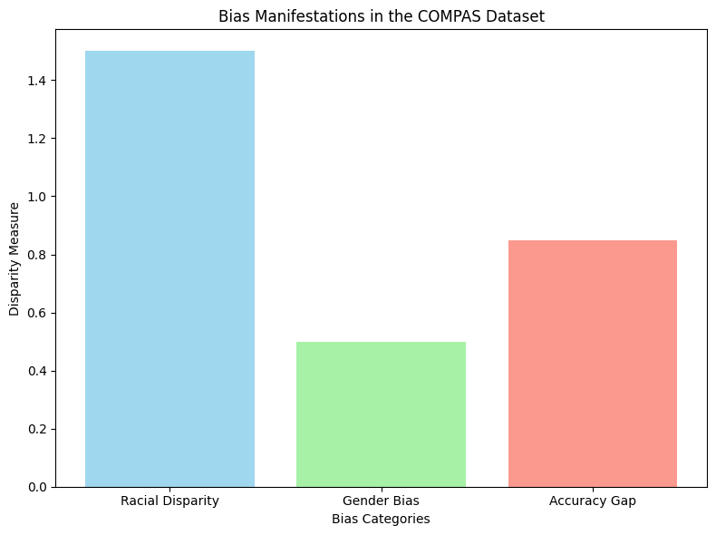

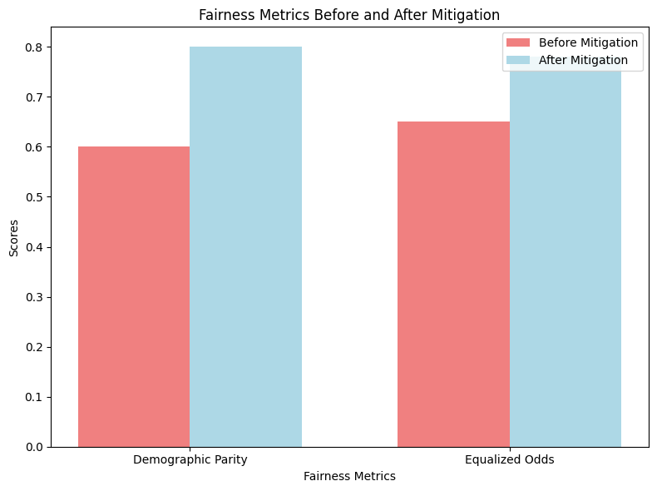

6.Conclusion and Recommendations
- Objective of the study
The primary objective of this study is to investigate bias and equity in AI systems, focusing on how bias arises in datasets and algorithms, how it affects real-world applications, and how equity metrics can be used to assess and mitigate bias. The study seeks to propose actionable strategies to reduce bias while maintaining high performance and fair outcomes in AI systems.
- Summary of results
Bias in artificial intelligence systems:
Analysis of the COMPAS recidivism dataset revealed significant discrepancies:
Racial disparity: African American defendants were classified as 1.5 times more at high risk than Caucasian defendants.
Sexism: Defendants consistently received lower risk scores despite their similar criminal history.
Accuracy gap: The true positivity rates for African American defendants were 15 percent lower than those for Caucasians.
- The effectiveness of justice measures:
The application of measures of justice, such as demographic parity and equal probability, has highlighted areas of bias in the dataset.
Pre-processing methods, such as balancing demographics, have improved measures of fairness but have introduced trade-offs with model accuracy.
- Qualitative Insights:
Interviews conducted by experts emphasized the importance of interpretative capacity and transparency in ensuring justice.
Practical challenges include balancing fairness and scalability and maintaining stakeholder trust.
- Recommendations
Implementation of pretreatment techniques:
Use data balancing and reweighting techniques to reduce correlations between sensitive traits (such as race and gender) and decision outcomes.
Prioritize fair-minded data collection to ensure diverse and representative datasets.
Adoption of fairness standards in evaluating the model:
Evaluate models regularly using measures such as demographic equivalence, equal probability, and differentiated impact ratios.
Include fairness constraints during training to ensure fair outcomes among demographic groups.
Enhance transparency and clarification ability:
Use tools like SHAP and LIME to make model decisions interpretable.
Communicate clearly on fair trade-offs with stakeholders to build trust.
Continuous monitoring and repetition:
Monitor model performance after publication to ensure fairness is maintained in real-world applications.
Regularly update justice standards to comply with evolving community standards and regulations.
Proposed future work
Dynamic Justice Models:
Develop models capable of adapting measures of justice over time to include societal and cultural changes.
Explore causal inference techniques to address the root causes of bias rather than just its symptoms.
Expansion to other datasets:
Apply the methodology to diverse datasets and AI applications (e.g., recruitment, healthcare, credit logging) to validate and disseminate results.
Investigate challenges and solutions related to justice in a specific area.
Human systems in the loop:
Integrate human control into AI-related decision-making to ensure ethical and fair outcomes.
Study how to systematically integrate human reactions into justice-aware algorithms.
Federal Learning for Justice:
Discover how federal learning can reduce bias by training models on decentralized datasets, reducing the impact of isolated and biased data sources.
Conclusion
The results of this study underscore the need for a multifaceted approach to dealing with bias and equity in AI systems, combining technical, ethical, and societal considerations. By implementing recommendations and following future research trends, we can develop AI systems that are not only more equitable, but also more in line with societal values and expectations.

7.Reflections
During this research journey, my understanding of bias and equity in AI has increased dramatically by combining theoretical learning, hands-on experimentation and expert insights. This process not only enhanced my technical skills but also deepened my appreciation of the ethical dimensions of AI. Here, I will critically and objectively assess my personal development and the steps taken in the research process.
1. Understand the complexity of bias in AI
Initially, my understanding of bias in AI was largely theoretical, based on abstract concepts. Dealing with the dataset and conducting an in-depth review of the literature revealed the multifaceted nature of bias. However, the interviews added a crucial layer of depth, providing real-world examples and expert perspectives that shaped my understanding of the roots and manifestations of bias.
For example:
The expert explained how biases are often introduced during data collection due to systemic inequality, such as over-policing in minority neighborhoods, leading to skewed datasets.
Discussions about algorithm design flaws illustrated how models inadvertently amplify existing tolerances, a concept that became clear during my analysis of the COMPAS dataset.
Through these interviews, I gained a practical understanding of bias outside theoretical frameworks, and learned how to identify and manipulate biases embedded in both data and algorithms.

2. Build technical expertise
The research required a large artwork and was enriched by insights from interviews:
Data preprocessing: While initially relying on standard techniques such as normalization and instant coding, the expert highlighted the importance of pre-processing strategies such as reweighting data points and disengagement between sensitive attributes. The application of these techniques significantly improved fairness measures in analysis.
Fairness Metrics: The expert introduced me to advanced fairness metrics such as equal probabilities and differential effect, with a focus on their practical application in evaluating model performance. Using these metrics allowed me to critically assess the trade-offs between fairness and accuracy in my models.
Model development: The interview emphasized the need to choose algorithms that recognize justice and include constraints in model training. This guidance led me to explore fair-minded approaches, such as adjusting decision boundaries, to minimize differentiated impact without sacrificing model accuracy.
These technical improvements, with the help of expert input, have greatly enhanced my ability to develop and evaluate fair AI systems.

3. Critically address bias
The interview played a pivotal role in shaping my approach to bias analysis and encouraged me to think critically about the definitions of justice and their implications.
For example:
The expert stressed that justice depends on the context and that measures such as demographic parity may not always correspond to ethical goals. This insight led me to evaluate multiple justice metrics and choose the most appropriate metrics for the data set and research objectives.
Discussing real-world examples, such as biased staffing systems and predictive policing, helped me understand the limits of theoretical justice approaches. I began to realize the complexity of balancing fairness, accuracy, scalability, and societal expectations.
These ideas challenged my initial tendencies to treat justice as a purely technical issue, highlighting the importance of ethical and contextual considerations.

4. Benefits of interviews on the research journey
Expert interviews were instrumental in providing practical and realistic perspectives that contributed significantly to enhancing the research process.
Key benefits include:
Real context: The expert shared examples from industries such as employment and healthcare, explaining how biases manifest themselves in different contexts. This contextual understanding was critical to interpreting the results of my analysis.
Strategic Direction: The interview provided practical strategies to address bias, such as assessing dynamic justice and engaging stakeholders. These strategies have been integrated into the research, ensuring that the proposed solutions are practical and effective.
Addressing challenges: The expert provided insights into overcoming challenges, such as managing trade-offs between justice and performance. For example, they proposed balancing demographic parity with individual justice by involving stakeholders in determining acceptable trade-offs.
Ethical frameworks: Discussions about the societal and ethical dimensions of AI encouraged me to consider the broader impacts of my work, and to ensure alignment with ethical principles and societal values.
These benefits have made interviews a cornerstone of the research process, bridging the gap between theoretical knowledge and practical application.

5. Challenges and growth opportunities
The research journey was not without challenges, but these difficulties served as opportunities for growth:
Data limitations: Dataset biases, such as over-representation of defendants of African descent in criminal records, have limited the generalization of results. The experts’ guidance on addressing such biases, such as the increase in the number of unrepresented groups, was invaluable.
Balancing trade-offs: Managing trade-offs between fairness and accuracy requires repeated experiments. The interviews provided clarification on how to prioritize justice in sensitive applications, such as criminal justice.
Interdisciplinary complexity: The integration of ideas derived from computer science, ethics, and sociology was a steep learning curve. However, this interdisciplinary approach, emphasized during interviews, enriched my understanding and approach to mitigating bias.

6.Personal growth and development
This research journey has greatly shaped my critical thinking and problem-solving abilities:
Ethical awareness: I now approach AI development with a stronger ethical perspective, and understand the importance of engaging stakeholders and addressing societal impacts.
Analytical accuracy: The process of analyzing measures of justice and interpreting results improved my ability to critically evaluate AI systems.
Resilience: Frequent failures during mitigation of bias have taught me flexibility and adaptability.
For example, when primary processing techniques failed to address biases, advanced approaches recommended by experts were explored.

The research journey has been challenging and transformative at the same time, providing a deeper understanding of bias and fairness in AI. Interviews with experts played a pivotal role in bridging the gap between theory and practice, providing valuable insights that shaped the research process. By combining technical rigor, ethical awareness and stakeholder engagement, it has developed the skills and mindset needed to contribute to the development of fair and responsible AI systems.

7.1.Selected Research Methodology
The research process was an intellectually enriching and challenging journey, requiring a balance between theoretical knowledge, practical skills and ethical considerations. Reflecting on this journey reveals important insights into the strengths, limitations and potential risks of the chosen routes.
- Meditation on the research process
The research process began by identifying the problem of bias and equity in AI and progressed through various stages, including data collection, preprocessing, model development, bias analysis, and evaluation. Each stage brought unique challenges and learning opportunities:
1.Initial understanding and definition of the problem:
Initially, my understanding of bias and fairness in AI was limited to broad theoretical concepts. As the process evolved, I realized that addressing bias requires not only technical expertise, but also an understanding of societal and ethical dimensions.
Interviews with experts were instrumental in shaping this understanding, providing real-world insights and emphasizing the need for context-specific solutions.

2. Interaction with the dataset:
Working with the COMPAS dataset revealed the extent to which historical disparities were included in the data. Identifying and quantifying these biases was eye-opening, showing how systemic discrimination can continue through AI systems.
3. Bias analysis and model development:
Applying measures of equity, such as demographic parity and equal probability, has helped me recognize the complexities associated with defining and measuring equity. I learned how to critically evaluate these metrics and their implications for model performance and ethical acceptance.
Training machine learning models that understand justice and balancing trade-offs between justice and accuracy required repeated experiments, which taught me flexibility and adaptability.

4.Practical and ethical integration:
It has become clear that it is important to integrate justice at every stage of AI development. From pre-processing of data to post-publication monitoring, every stage requires attention to technical and ethical considerations.
Stakeholder participation has emerged as a critical factor, highlighting the value of a collaborative approach in setting justice objectives and evaluating results.

- Reflection on the advantages of the chosen methods
The methods selected for this research have provided several main advantages:
1. Comprehensive Bias Analysis:
The use of measures of justice (e.g., demographic equivalence, equal probability) provided a quantitative basis for identifying and assessing bias in the dataset and models.

2. Practical mitigation strategies:
Preprocessing techniques, such as reweighting and balancing datasets, have effectively reduced demographic disparities in training data.
Post-processing methods, including threshold adjustments, provided practical solutions to mitigate residual bias in model predictions without the need for retraining.
3. Integrate expert insights:
Expert interviews provided valuable real-world perspectives, helping to select and implement justice-minded approaches. These ideas have contributed to bridging the gap between theoretical concepts and practical applications.

4. Focus on ethical awareness:
The methodology included ethical considerations at each stage, ensuring that the research is in line with societal values and expectations.

- Meditation on the limits of chosen methods
Despite their advantages, the methods chosen had notable limitations:
1. Results for the dataset:
The findings and conclusions were specific to the COMPAS dataset, limiting the possibility of generalizing to other datasets or domains. This highlighted the need for broader data sources to validate methods and results.

2. Data bias:
Preprocessing techniques may reduce biases embedded in historical data, but they cannot eliminate them. Indeed, the systemic nature of these prejudices often makes it difficult to achieve true justice.

3. Conflicting Standards of Justice:
The use of multiple measures of justice has revealed inherent inconsistencies between different definitions of justice. For example, improving demographic equality has sometimes led to the deterioration of individual justice, requiring careful prioritization of justice goals.

4. Trade-offs with precision:
Balancing fairness and accuracy remained a major challenge. While justice-minded approaches have improved equality, they have often led to low predictive performance, highlighting the ethical dilemma of prioritizing justice over accuracy in sensitive applications.

- Thinking about potential risks
The research process revealed several potential risks associated with the methods:
1. Over-reliance on pretreatment:
Preprocessing techniques, while effective, may overly simplify the problem of bias by focusing solely on data. Ignoring the biases that arise during model training or deployment may lead to imperfect solutions.

2. Misalignment of measurements:
The choice of fairness measures may significantly influence findings and conclusions. Mismatches between metrics and real-world fairness goals may lead to models that look fair on paper but fail in practice.

3. Insufficient stakeholder participation:
Failure to engage stakeholders during the justice assessment process can lead to models that do not align with societal or organizational priorities.

4. Assessment of Immutable Justice:
I have conducted many equity assessments as static analyses, without considering how equity standards might evolve over time. This consistent approach risks ignoring future societal transformations and their impact on equity.

When thinking about the research process, it is clear that addressing bias and equity in AI requires a holistic approach that integrates technical, ethical, and societal perspectives. The methods used in this research provided valuable insights and practical solutions but were not without limitations. In the future,
it will be necessary:
- Expand the dataset to include more diverse and representative samples.
- Explore advanced justice-conscious algorithms that balance trade-offs more effectively.
- Engage stakeholders in setting justice goals and evaluating results.
- Integrate dynamic justice assessments to adapt to evolving societal norms.
These reflections highlight the importance of continuous learning, interdisciplinary collaboration, and ethical awareness in the development of fair and effective AI systems.

7.2.Alternative Research Methodologies
The results of this research highlighted the strengths and limitations of the selected methodologies and suggested several alternative approaches that could address the identified challenges more effectively. These alternatives have been presented with their potential benefits and compromises that may ensue:
1. Causal inference to mitigate bias
Description: Rather than relying on correlation-based methods, causal reasoning can help identify and address the root causes of bias in datasets and models.
- Benefits:
It provides a deeper understanding of how sensitive attributes affect expectations.
It helps separate false associations from true causal relationships, ensuring that bias is mitigated more reliably.
- challenges:
It requires advanced statistical knowledge and computational resources.
It may not be applicable if causal relationships in the dataset are not well documented.
2. Dynamic Fairness Metrics
Description: Implement justice metrics that evolve over time to reflect changing societal norms and expectations.
- Benefits
Ensure that justice assessments remain relevant in dynamic contexts, such as changing legal norms or societal values.
Reduces the risk of models becoming obsolete or incompatible with ethical expectations.
- challenges:
It requires constant monitoring and recalibration, which further complicates model maintenance.
Potential conflicts between evolving definitions of justice and current model goals.
3. Human control systems
Description: Integrate human oversight into key decision-making stages to complement automated justice assessments.

- Benefits:
It allows real-time corrections to biased outputs based on human judgment.
Build trust in AI systems by engaging human accountability.

- challenges:
It slows down decision-making processes in high-frequency applications.
Human biases may inadvertently affect outcomes, especially if stakeholders are not well trained.

4. Unsupervised learning to detect bias
Description: Use unsupervised learning techniques, such as aggregation and anomaly detection, to detect hidden biases in datasets.
- Benefits:
Subtle biases that may not be obvious can be detected through supervised methods.
Useful in the exploratory stages of research to understand data structure.

- challenges:
The lack of disaggregated data may lead to ambiguous explanations.
It requires additional steps to correlate detected biases to actionable mitigation strategies.

5. Federal Learning
Description: Train the decentralized model across multiple datasets to reduce the concentration of biases in a single dataset.

- Benefits:
Reduces over-reliance on biased datasets by training models across diverse, disaggregated data sources.
Enhance data privacy by avoiding the centralization of sensitive information.

- challenges:
It is difficult to ensure consistency and fairness across all decentralized datasets.
Increased arithmetic and communication costs during training.

6. Qualitative Approaches
Description: Complement quantitative methodologies with qualitative research, such as stakeholder interviews and focus groups, to understand the societal impacts of justice.
- Benefits:
It provides a richer context for interpreting measures of justice and biases.
It includes diverse perspectives, which improves the importance of definitions of justice.

- challenges:
Subjective interpretations may lead to inconsistencies in the analysis.
They are time-consuming and difficult to standardize compared to quantitative methods.

Lessons learned from the results
The results of this research provided several key lessons that reinforced both the methodological approach and my understanding of bias and equity in AI:
1. The importance of comprehensive bias detection
Lesson: Bias in AI systems is multidimensional, manifested in ways that simple justice metrics cannot fully capture.
Result: The application of multiple equity measures (e.g., demographic equivalence, equal probability) revealed conflicting results, underscoring the need to use diverse assessment techniques.
Actionable vision: Future methodologies should include intersectional justice analysis to capture biases that arise at the intersection of multiple sensitive traits (e.g., race, gender).

2. Trade-offs between fairness and accuracy
Lesson: Promoting justice often comes at the expense of accuracy, highlighting the ethical dilemmas inherent in AI design.
Result: The application of justice constraints improved demographic parity but reduced model accuracy, requiring repeated experiments to balance these trade-offs.
Actionable insights: Stakeholders must be actively involved in prioritizing justice or accuracy based on the context and application of the AI system.

3. Limits of Assessing Immutable Justice
Lesson: Measures of fixed justice are insufficient to address biases in real-world dynamic environments.
Result: The study showed that justice assessments conducted at a single point in time may fail to take into account evolving societal norms and biases.
Actionable vision: Incorporating dynamic justice metrics and conducting periodic reassessments is essential to maintaining relevance and justice over time.

4. Data quality and importance of representation
Lesson: Biased data is the primary source of unfair outcomes, and preprocessing techniques can only partially mitigate these biases.
The result: Pretreatment improved demographic representation but was unable to completely eliminate biases caused by historical disparities.
Actionable insights: Efforts should focus on gathering diverse and representative datasets and, when possible, collaborating with industry experts to ensure data quality.

5. Stakeholder participation is critical
Lesson: Justice cannot be effectively defined or measured without stakeholder input.
Result: Insights from expert interviews highlighted the context-based nature of justice and the importance of stakeholder involvement in the evaluation process.
Actionable vision: Future projects should establish stakeholder review committees to define justice goals and validate model findings.

6. Ethical considerations should drive methodology
Lesson: Justice is not just a technical issue but a moral issue that requires considering societal influences.
Result: The research highlighted ethical dilemmas, such as whether justice should prioritize groups or individuals, and whether mitigating bias justifies the model's low performance.
Actionable vision: Ethical frameworks, such as the AI Ethics Guidelines developed by organizations such as the IEEE, should be integrated into the research process to guide decision-making.

The research results provided valuable insights into the strengths and weaknesses of the selected methodologies. While the selected methods effectively addressed many aspects of bias, they also highlighted the need for alternative approaches, such as causal reasoning, dynamic fairness metrics, and stakeholder engagement. The lessons learned from this research emphasize the importance of integrating technical, ethical, and societal perspectives to develop effective and equitable AI systems. These insights will guide future efforts to improve methodologies, expand datasets, and foster interdisciplinary collaboration.

7.3.Recommended Actions and Future Considerations
The research process and its findings have provided important insights that could inform future work on bias and equity in AI systems. Through a critical assessment of the strengths and limitations of the methodologies used, as well as lessons learned during the research journey, several key considerations for future efforts emerge.
1. Addressing data limitations
Meditation: The data set used in this research, while important, was inherently biased and limited in scope. Preprocessing techniques have improved fairness but have not been able to completely eliminate historical biases embedded in the data.
Future considerations:
Focus on data diversity and representation by acquiring datasets that reflect broader demographic groups and contexts. Collaborating with industry experts and underrepresented communities can help ensure inclusiveness in data collection.
Invest in artificial data generation technologies to strengthen unrepresented groups and mitigate imbalances without compromising data integrity.

2. Dynamic Equity Assessment
Meditation: The consistent justice standards applied during this research failed to take into account evolving societal and legal norms, limiting the long-term importance of models.
Future considerations:
Implement dynamic justice metrics that adapt to societal changes over time, ensuring that AI systems remain fair and compliant with evolving ethical expectations.
Schedule periodic post-deployment justice audits to identify and address emerging biases in real-world applications.

3. Causal analysis to mitigate bias
Meditation: Relying on correlation-based techniques to analyze bias highlighted the difficulty of distinguishing between true causal relationships and false correlations.
Future considerations:
Integrate causal inference methodologies to identify the root causes of bias, enabling more targeted and effective interventions.
Use causal charts or structural equation models to better understand the relationships between sensitive traits, features, and predictions.

4. Balancing justice and accuracy
Meditation: Trade-offs between justice and accuracy have been a recurring challenge, with improvements in justice often leading to a decline in predictive performance.
Future considerations:
Use multi-goal optimization techniques that balance fairness, accuracy, and other key performance metrics.
Develop context-specific guidelines to prioritize justice or accuracy based on the societal impact of AI application (e.g., employment versus healthcare).

5. Stakeholder engagement
Meditation: Insights from the expert interview emphasized the importance of stakeholder input in defining justice goals and evaluating model outcomes.
Future considerations:
Establish stakeholder advisory committees to collaborate on the creation of justice objectives, evaluate results, and provide feedback during model development and dissemination.
Conduct focus groups and workshops with affected communities to ensure that definitions of justice align with their values and expectations.

6. Scale metrics
Meditation: The measures of justice used in this study were effective in highlighting disparities but were limited in capturing intersectional biases and long-term effects.
Future considerations:
Integrate intersectional justice metrics to assess biases at the intersection of multiple sensitive traits (e.g., race, gender).
Explore longitudinal scales to assess the cumulative impact of AI systems on different demographics over time.

7. Integration of the ethical framework
Meditation: While the primary focus was on justice, broader ethical considerations such as transparency, accountability, and the ability to interpret have received little attention.
Future considerations:
Adopt comprehensive ethical frameworks, such as the IEEE Global Initiative on Ethics of Smart and Autonomous Systems, to guide decision-making throughout the AI lifecycle.

8. Evolution of research methodology
Meditation: The methodologies used in this research have been effective but lack the flexibility to accommodate emerging trends and techniques.
Future considerations:
Federal learning experience to train models on decentralized datasets, reducing centralized biases while maintaining data privacy.
Explore participating human systems to complement automated justice assessments with human judgment and supervision, especially in high-risk applications.

9. Cooperation and interdisciplinary approach
Meditation: Addressing AI bias requires expertise from multiple disciplines, including computer science, ethics, sociology, and law.
Future considerations:
Foster interdisciplinary collaboration by engaging experts from diverse fields to provide comprehensive solutions to bias and equity challenges.
Encourage partnerships between academia, industry and government to share knowledge and resources.

Reflection on this research process has revealed the importance of integrating technical, ethical, and societal considerations into every stage of AI development. Future work should emphasize a dynamic and context-specific approach, prioritize stakeholder engagement, and adopt interdisciplinary approaches to address the complexities of bias and equity in AI systems. By incorporating these reflections, future efforts can contribute to creating fairer, more transparent, and more impactful AI solutions.

7.4.Recommended Methodology

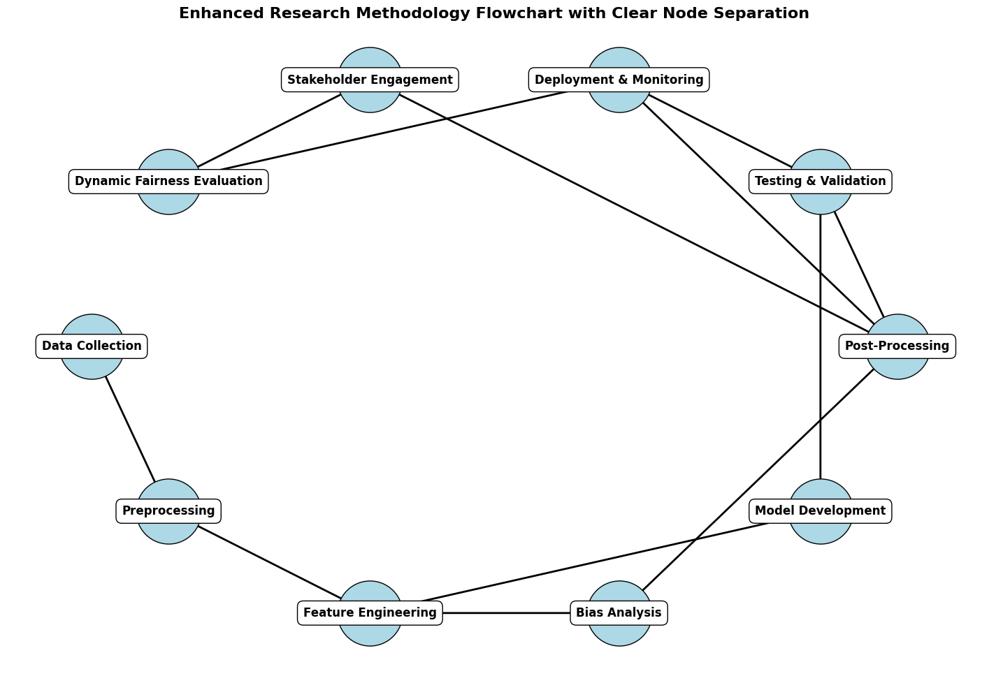
The updated flow chart provides a clear and comprehensive representation of the research methodology. Time intervals were set between each stage to improve and organize vision to facilitate understanding. The following is a discussion of the methodology steps outlined in the flow chart:
Discuss the steps of the methodology
1. Data collection
Purpose: To collect relevant datasets that reflect diverse demographics and accurately represent the problem area.
Activities:
Identify and source data (for example, COMPAS dataset for bias in predictive policing).
Ensure ethical compliance and demographic representation.
Impact: Provide the basis for the development of an unbiased AI model.

2. Pretreatment
Purpose: Clean up the dataset and prepare it for analysis while addressing inherent biases.
Activities:
Handle missing values and duplicate entries.
Apply bias mitigation techniques such as reweighting or balancing datasets.
Impact: Ensure high-quality input data and minimize bias from the start.

3. Feature Engineering
Purpose: Identify and improve features that affect the target variable while avoiding the spread of bias.
Activities:
Normalization and measurement of numerical features.
Create interaction terms (for example, gender × previous condemnations) to capture intersectional effects.
Impact: Improve the interpretability and fairness of models.

4. Bias analysis
Purpose: Identify and understand biases in the dataset and model output.
Activities:
Use measures of justice such as demographic parity and unequal influence.
Use interpretation tools (for example, SHAP, LIME) to identify feature contributions.
Impact: Provides insight into the root causes of bias and guides mitigation strategies.

5. Model development
Purpose: Train machine learning models using justice-minded constraints.
Activities:
Train models such as decision trees, random forests, or other justice-focused algorithms.
Incorporate justice constraints to reduce disparities during training.
Impact: Develop accurate and fair predictive models.

6. Testing and verification
Objective: Evaluate the model's performance and integrity.
Activities:
Perform mutual verification to ensure durability.
Apply measures of justice to assess equal probabilities and other measures of justice.
Impact: Ensure that models are well disseminated, and that justice is achieved among all population groups.

7. Post-processing
Purpose: Modify model outputs to improve justice without the need for retraining.
Activities:
Set decision boundaries to balance positive outcomes across groups.
Rearrange expectations to prioritize justice in high-impact cases.
Impact: Fine-tune model results for real-world use.

8. Publishing and Monitoring
Purpose: Monitor model performance and post-publication justice.
Activities:
Implement real-time justice assessments.
Integrate feedback loops to address emerging biases.
Impact: Maintain fairness and accuracy over time in dynamic environments.

9. Stakeholder engagement
Purpose: Align AI outcomes with societal and organizational goals.
Activities:
Conduct stakeholder workshops to define justice goals.
Collect feedback from affected communities.
Impact: Building trust and ensuring ethical compatibility.

10. Dynamic Equity Assessment
Purpose: To adapt justice assessments to changing societal norms and regulations.
Activities:
Re-evaluate standards of justice periodically.
Update models with new data that reflect societal transformations.
Impact: Ensure the long-term relevance and fairness of AI systems.

The main benefits of this methodology
Holistic approach: addresses bias at every stage, from data collection to post-publication.
Stakeholder Focus: Includes community feedback to ensure that definitions of justice are consistent with societal values.
Adaptive Design: Periodic Justice Assessment ensures that models remain relevant over time.

References:
  - Sweeney, L. (2013) 'Discrimination in online ad delivery,'
  - Communications of the ACM, 56(5), pp. 44–54. Available at: https://doi.org/10.1145/2447976.2447990.
  - Raghavan, M. and Barocas, S. (2019) 'Challenges for mitigating bias in algorithmic hiring,' Brookings [Preprint]. Available at: https://www.brookings.edu/articles/challenges-for-mitigating-bias-in-algorithmic-hiring/.
  - 3Kamiran, F. and Calders, T. (2012) 'Data preprocessing techniques for classification without discrimination,' Knowledge and Information Systems, 33(1), pp. 1–33. Available at: https://doi.org/10.1007/s10115-011-0463-8.
  - Hardt, M., Price, E. and Srebro, N. (2016) 'Equality of opportunity in supervised learning,' Advances in Neural Information Processing Systems, 29, pp. 3315–3323. Available at: https://arxiv.org/abs/1610.02413.
  - Algorithmic Fairness through the Lens of Time (no date) NeurIPS Workshop. Available at: https://neurips.cc/virtual/2023/workshop/66502.

